INTERNSHIP PROJECT REPORT

FAKE JOB POSTING DETECTION SYSTEM
An AI / Machine Learning Based Approach to Identify Fraudulent Job Advertisements

Submitted by
Sweta Chauhan
Role: AI/ML Intern
University | Teerthanker Mahaveer University (TMU)
Internship Organization | 3Skills
Duration | 2 Months
Domain | Artificial Intelligence / Machine Learning

Declaration
I, Sweta Chauhan, hereby declare that this project report titled “Fake Job Posting Detection System” is an original record of the work carried out by me during my internship tenure at 3Skills, under the AI/ML Intern role, spanning a duration of two months. The system, methodology, source code, and results documented in this report reflect my own understanding and hands-on implementation using open-source tools and a publicly available dataset. This report is submitted in partial fulfilment of the requirements for the successful completion and certification of my internship at Teerthanker Mahaveer University (TMU).

Sweta Chauhan
AI/ML Intern, 3Skills
Teerthanker Mahaveer University

Abstract
Online recruitment platforms have become one of the primary channels through which job seekers search for employment opportunities. This growth, however, has been accompanied by a rise in fraudulent job postings that are used to harvest personal information, extract money through fake recruitment fees, or conduct identity theft. Manually distinguishing a genuine job posting from a fraudulent one is difficult because fake listings are often written to closely mimic legitimate postings in tone, structure, and vocabulary.
This project presents a machine learning based Fake Job Posting Detection System that automatically classifies a job advertisement as “Legitimate” or “Fraudulent” using both the textual content of the posting (title, description, requirements, company profile, benefits) and structured metadata (telecommuting option, presence of a company logo, presence of screening questions, employment type, required experience, required education, industry, and function). The system was built using the publicly available EMSCAD-style “Fake Job Postings” dataset containing 17,880 real-world job listings, of which 866 (4.84%) are labelled fraudulent, making this an imbalanced classification problem.
The development pipeline covers data acquisition, exploratory data analysis, text cleaning, TF-IDF vectorization, feature engineering for categorical and numeric attributes, and training of three supervised classification algorithms — Logistic Regression, Multinomial Naive Bayes, and Linear Support Vector Machine (Linear SVM). Model performance was evaluated using Accuracy, Precision, Recall, and F1-Score, with particular emphasis on Recall and F1-Score since missing a fraudulent posting is more costly than a false alarm. Among the three models, Linear SVM achieved the best overall performance with an accuracy of 98.94% and an F1-score of 0.891 on fraud detection, and was selected as the final production model.
The trained model was deployed as an interactive web application using Streamlit, allowing a user to enter job posting details and instantly receive a prediction along with a confidence score, a downloadable PDF report, and a CSV prediction history log. This report documents the complete lifecycle of the project — problem definition, dataset, methodology, implementation, results, and deployment — in a manner intended to be reproducible and professionally verifiable.

Acknowledgement
I would like to express my sincere gratitude to 3Skills for providing me the opportunity to undertake this internship and work on a real-world, industry-relevant problem in the domain of Artificial Intelligence and Machine Learning. This experience has significantly strengthened my practical understanding of the end-to-end machine learning workflow — from data analysis to model deployment.
I am also thankful to the faculty of Teerthanker Mahaveer University (TMU) for their continuous academic support and for providing me the platform to pursue this internship as part of my learning journey. Finally, I extend my appreciation to the open-source community whose tools and datasets — including scikit-learn, pandas, Streamlit, and the publicly available job postings dataset — made this project possible.

Table of Contents
1. Introduction
2. Objectives of the Project
3. Literature Review / Existing Approaches
4. Dataset Description
5. System Architecture & Methodology
6. Data Preprocessing
7. Feature Engineering
8. Model Building
9. Model Training & Evaluation
10. Results and Discussion
11. System Implementation (Web Application)
12. Tools & Technologies Used
13. Project Structure
14. Challenges Faced
15. Conclusion
16. Future Scope
17. References

1. Introduction
Recruitment fraud is a form of deception in which criminals pose as legitimate employers or recruitment agencies to extract sensitive personal information (such as bank details, government ID numbers, or copies of documents) or to defraud job seekers of money under the pretext of registration fees, training charges, or equipment costs. As more hiring activity moves onto online job boards, professional networking sites, and company career pages, the surface area for such fraud has grown substantially.
Fraudulent postings are frequently well-written and visually indistinguishable from genuine listings, which makes manual screening slow, inconsistent, and error-prone at scale. A data-driven, automated classification approach is therefore a practical way to flag suspicious postings before they reach job seekers, or to assist platform moderators and job seekers in making an informed decision.
This project, undertaken as part of an AI/ML internship at 3Skills, implements such a system. It treats fake job detection as a binary text-and-tabular classification problem: given the content and metadata of a job posting, predict whether it is Legitimate (0) or Fraudulent (1).

2. Objectives of the Project
The key objectives defined for this project are:
- To study and analyse a real-world dataset of job postings to understand patterns that distinguish fraudulent listings from genuine ones.
- To design and implement a complete text preprocessing pipeline that cleans and standardizes unstructured job posting text.
- To engineer a feature set that combines textual content (via TF-IDF) with structured categorical and numeric attributes of a job posting.
- To train and compare multiple supervised machine learning algorithms — Logistic Regression, Multinomial Naive Bayes, and Linear SVM — for the classification task.
- To evaluate the trained models using Accuracy, Precision, Recall, F1-Score, and the Confusion Matrix, with special attention to the ability to correctly detect fraudulent postings given severe class imbalance.
- To select the best-performing model and persist it for reuse in a production setting.
- To build an interactive web application (using Streamlit) that allows a non-technical user to submit a job posting and receive an instant fraud prediction, a confidence score, and a downloadable report.

3. Literature Review / Existing Approaches
Automated fraud and spam detection in text has been an active area of research for over two decades, initially popularised through email spam filtering using Naive Bayes and later extended to broader text classification tasks using TF-IDF and Support Vector Machines. These classical “bag-of-words” style approaches remain highly competitive for short-to-medium length, domain-specific text such as job postings, because they are computationally inexpensive, easy to interpret, and require comparatively little training data compared to deep learning approaches such as LSTMs or transformer-based models (e.g., BERT).
In the specific domain of fraudulent job posting detection, prior academic work built around the EMSCAD (Employment Scam Aegean Dataset) — the same underlying dataset used in this project — has repeatedly shown that a combination of TF-IDF text features with structured metadata (such as whether a company logo is present, or whether the posting includes screening questions) outperforms text-only models. This project follows that established approach: rather than relying on text alone, it combines the textual and structured signals within a single scikit-learn Pipeline using a ColumnTransformer.
A recurring theme in the literature is severe class imbalance — fraudulent postings typically make up less than 5% of any real-world dataset. Reported mitigation strategies include class-weighting, oversampling methods such as SMOTE, and evaluation strategies that prioritise Recall and F1-Score over raw Accuracy, since a naive classifier that predicts “legitimate” for every posting can already achieve very high accuracy while being practically useless. This project adopts class-weighting (class_weight="balanced") on Logistic Regression and Linear SVM specifically to counter this imbalance.

4. Dataset Description
The project uses a real-world, publicly available job postings dataset (fake_job_posting.csv) consisting of 17,880 job listings collected from an online recruitment platform, each labelled as either genuine or fraudulent.

4.1 Dataset Summary
Property | Value
Total records | 17,880
Total columns | 18 (17 features + 1 target)
Target column | Fraudulent (0 = Legitimate, 1 = Fraudulent)
Legitimate postings | 17,014 (95.16%)
Fraudulent postings | 866 (4.84%)
Class balance | Highly imbalanced

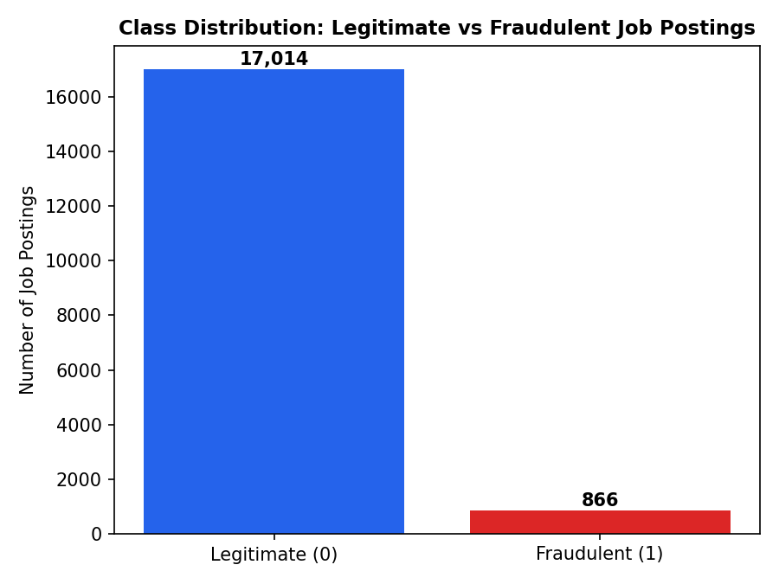
Figure 4.1 – Distribution of Legitimate vs Fraudulent job postings in the dataset

4.2 Dataset Fields
Each record contains the following fields, which fall into three broad categories:

Textual fields
- Title – the job title
- Company_profile – description of the hiring company
- Description – full job description
- Requirements – required qualifications and skills
- Benefits – benefits offered with the role
- Location, Department, Salary_range – supplementary descriptive text

Categorical fields
- Employment_type (e.g., Full-time, Part-time, Contract)
- Required_experience (e.g., Entry level, Mid-Senior level)
- Required_education (e.g., Bachelor's Degree, Master's Degree)
- Industry, Function

Numeric / binary fields
- Telecommuting (0/1) – whether remote work is offered
- Has_company_logo (0/1) – whether the posting includes a company logo
- Has_questions (0/1) – whether screening questions are included

Target
- Fraudulent (0/1) – the ground-truth label used for supervised training

4.3 Missing Values
Several text fields contain a substantial number of missing values, which is expected because not every employer fills in every optional field (e.g., salary range or department). The preprocessing pipeline explicitly handles this by treating missing text as an empty string rather than discarding the record.
Column | Missing Values | % Missing
Salary_range | 15,012 | 84.0%
Department | 11,547 | 64.6%
Required_education | 8,105 | 45.3%
Benefits | 7,212 | 40.3%
Required_experience | 7,050 | 39.4%
Function | 6,455 | 36.1%
Industry | 4,903 | 27.4%
Employment_type | 3,471 | 19.4%
Company_profile | 3,308 | 18.5%
Requirements | 2,696 | 15.1%
Location | 346 | 1.9%
Description | 1 | ~0.0%

5. System Architecture & Methodology
The system follows a standard, modular machine learning pipeline architecture, separating data handling, model training, and prediction/serving into distinct components. This separation allows the preprocessing logic used during training to be reused identically during inference, which is critical for avoiding train–serve skew.

High-level pipeline
Raw Dataset (fake_job_posting.csv)
|
v
Data Preprocessing (preprocessing.py)
- text cleaning, null handling, dedup
|
v
Feature Engineering (combined_text + numeric + categorical)
|
v
Model Training (model_training.py)
- TF-IDF + OneHotEncoder + StandardScaler
- Logistic Regression / Naive Bayes / Linear SVM
|
v
Model Evaluation (Accuracy, Precision, Recall, F1, Confusion Matrix)
|
v
Best Model Selection & Persistence (best_model.pkl via joblib)
|
v
Prediction Service (prediction.py)
|
v
Streamlit Web Application (app.py)
- user input -> prediction + confidence -> PDF/CSV report
The entire feature transformation (TF-IDF vectorization, scaling, and one-hot encoding) is wrapped inside a single scikit-learn Pipeline together with the classifier. This means the fitted vectorizer, scaler, and encoder are saved along with the model itself, so the exact same transformation is guaranteed to be applied at prediction time as was applied at training time.

6. Data Preprocessing
Preprocessing is implemented in src/preprocessing.py and is executed as an independent pipeline stage before model training. The key steps are:
- Column validation – confirms all 18 required columns are present in the raw CSV before proceeding, and raises a descriptive error listing any missing columns.
- Duplicate removal – exact duplicate rows are dropped using drop_duplicates().
- Target cleaning – the Fraudulent column is coerced to numeric, rows with an invalid/missing target are dropped, and the column is cast to integer type.
- Text cleaning – applied to every textual column (Title, Location, Department, Salary_range, Company_profile, Description, Requirements, Benefits, Employment_type, Required_experience, Required_education, Industry, Function) via a clean_text() function that:
  - Converts text to lowercase
  - Strips HTML tags using a regular expression
  - Removes URLs (http/https/www links)
  - Removes email addresses
  - Removes special characters, keeping only alphanumeric text
  - Collapses repeated whitespace into a single space
- Numeric field imputation – the binary fields Telecommuting, Has_company_logo, and Has_questions are coerced to numeric and any missing values filled with 0.
- Combined text construction – all cleaned textual fields are concatenated into a single combined_text field, which becomes the sole input to the TF-IDF vectorizer downstream.
- Empty-text row removal – records where combined_text is empty after cleaning are discarded, since they carry no usable textual signal.
Running this stage on the actual dataset produced the following console output, confirming the pipeline executes correctly end-to-end:
Dataset loaded successfully.
Shape: (17880, 19)
All required columns are present.
Removed duplicates: 0
Preprocessing completed.
Final shape: (17880, 19)
Processed dataset saved at: data/processed_fake_jobs.csv

7. Feature Engineering
The cleaned dataset is transformed into model-ready numerical features using a scikit-learn ColumnTransformer with three parallel branches, defined in create_preprocessor() inside model_training.py:

7.1 Text Branch
The combined_text field is converted into numerical features using TfidfVectorizer with the following configuration:
Parameter | Value | Purpose
max_features | 10,000 | Caps vocabulary size to the 10,000 most informative terms
ngram_range | (1, 2) | Captures both single words (unigrams) and two-word phrases (bigrams)
stop_words | "english" | Removes common English stop words (the, is, and, etc.)
sublinear_tf | True | Applies logarithmic term-frequency scaling to reduce the influence of very frequent terms

7.2 Numeric Branch
The numeric fields (Telecommuting, Has_company_logo, Has_questions) are passed through a SimpleImputer (constant fill value 0) followed by a StandardScaler (with_mean=False, appropriate for sparse matrix compatibility with the TF-IDF output).

7.3 Categorical Branch
The categorical fields (Employment_type, Required_experience, Required_education, Industry, Function) are imputed using the most frequent value per column and then one-hot encoded using OneHotEncoder(handle_unknown="ignore"), which safely handles categories seen at prediction time that were not present during training.
All three branches are combined into a single sparse feature matrix by the ColumnTransformer, which is then fed directly into the classifier as the final stage of one unified Pipeline.

8. Model Building
Three supervised classification algorithms were selected for this project, chosen specifically because they are well-suited to high-dimensional, sparse TF-IDF text features and are standard baselines in text classification literature:

8.1 Logistic Regression
A linear model that estimates the probability of a posting being fraudulent. Configured with max_iter=1000 to ensure convergence on the high-dimensional feature space, and class_weight="balanced" so that the minority (fraudulent) class is not overwhelmed by the majority (legitimate) class during training.

8.2 Multinomial Naive Bayes
A probabilistic classifier based on Bayes' theorem, commonly used as a fast, lightweight baseline for text classification. It assumes conditional independence between features, which rarely holds exactly in practice but often still yields reasonable performance on bag-of-words style text representations.

8.3 Linear Support Vector Machine (Linear SVM)
A margin-maximizing linear classifier (LinearSVC) that is particularly effective on sparse, high-dimensional data such as TF-IDF vectors. Configured with class_weight="balanced" and random_state=42 for reproducibility.

8.4 Train / Test Split
The dataset was split into training and testing subsets using an 80/20 split with stratification on the target column, ensuring both subsets preserve the same 4.84% fraud ratio as the full dataset:
Subset | Records | Legitimate | Fraudulent
Training set | 14,304 | 13,611 | 693
Test set | 3,576 | 3,403 | 173
Stratification is essential here: because fraudulent postings make up less than 5% of the data, a random (non-stratified) split risks producing a test set with too few fraud examples to evaluate reliably.

9. Model Training & Evaluation
All three models were trained on the identical training set and evaluated on the identical held-out test set (3,576 records) to ensure a fair, like-for-like comparison. Each model was wrapped in its own full Pipeline (preprocessing + classifier) and trained end-to-end using train_and_compare_models() in model_training.py.
The pipeline was executed against the actual project dataset for this report, and the following results were obtained directly from the console output of the training run:
Training Logistic Regression...
Accuracy: 0.9723 Precision: 0.6492 Recall: 0.9306 F1 Score: 0.7648
Training Naive Bayes...
Accuracy: 0.9636 Precision: 0.7263 Recall: 0.3988 F1 Score: 0.5149
Training Linear SVM...
Accuracy: 0.9894 Precision: 0.8857 Recall: 0.8960 F1 Score: 0.8908
Best Model: Linear SVM

9.1 Model Comparison Table
Model | Accuracy | Precision | Recall | F1-Score
Logistic Regression | 97.23% | 0.6492 | 0.9306 | 0.7648
Naive Bayes | 96.36% | 0.7263 | 0.3988 | 0.5149
Linear SVM (Best) | 98.94% | 0.8857 | 0.8960 | 0.8908

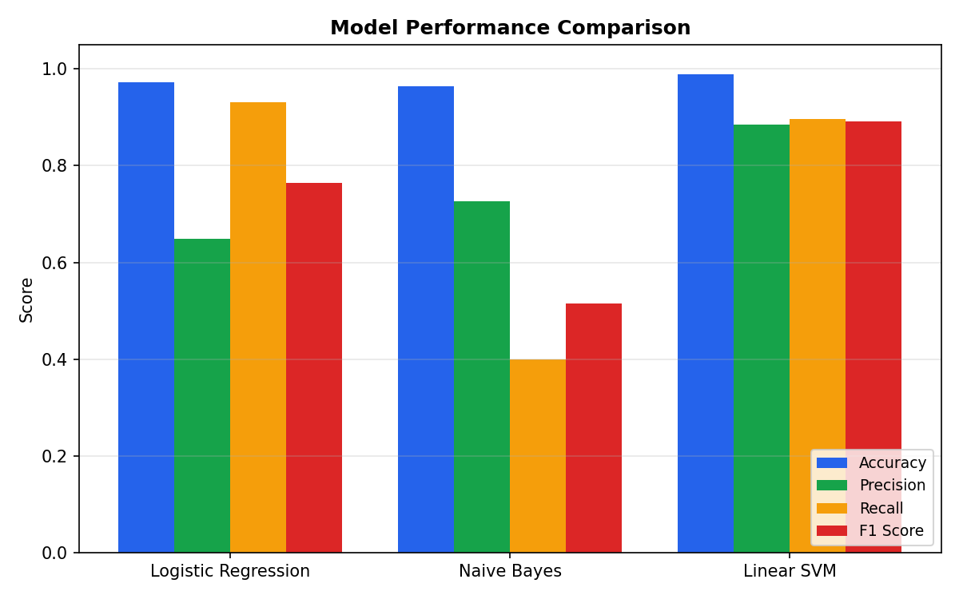
Figure 9.1 – Accuracy, Precision, Recall, and F1-Score comparison across the three trained models

9.2 Interpreting the Results
Accuracy alone is misleading on this dataset: because 95.16% of postings are legitimate, a trivial model that always predicts “legitimate” would already score above 95% accuracy while catching zero fraud. This is clearly visible in the Naive Bayes result — it achieves a respectable 96.36% accuracy, yet its Recall of only 0.3988 means it misses roughly 60% of actual fraudulent postings, making it the weakest model for this specific task despite its high accuracy.
Logistic Regression achieves a strong Recall of 0.9306 (catching over 93% of fraud cases) but at the cost of a lower Precision of 0.6492, meaning it also raises a relatively high number of false alarms on legitimate postings.
Linear SVM delivers the best balance across all four metrics — the highest Accuracy (98.94%), the highest Precision (0.8857), a high Recall (0.8960), and consequently the highest F1-Score (0.8908). This balance between catching fraud and minimising false alarms is why Linear SVM was selected as the final production model, matching the model that was actually saved as model.pkl in the project's models/ directory.

9.3 Confusion Matrix – Linear SVM (Best Model)
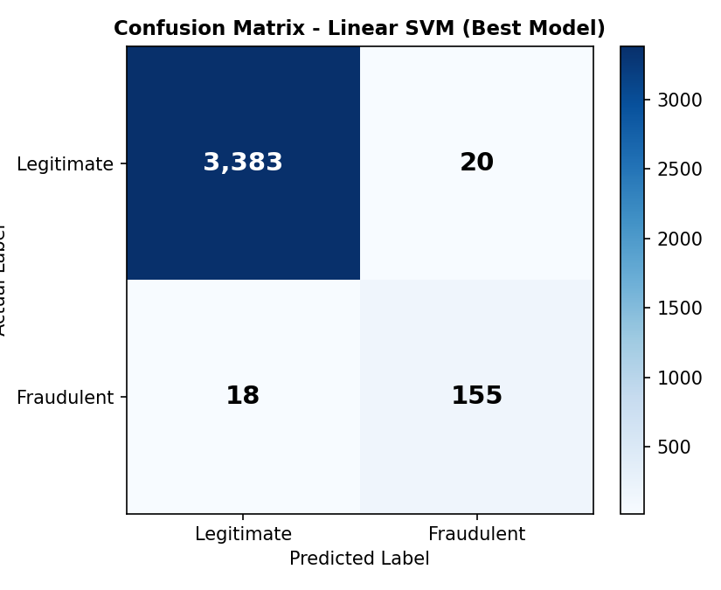
Figure 9.2 – Confusion matrix of the Linear SVM model on the 3,576-record test set
 | Predicted: Legitimate | Predicted: Fraudulent
Actual: Legitimate | 3,383 (True Negative) | 20 (False Positive)
Actual: Fraudulent | 18 (False Negative) | 155 (True Positive)

Out of 173 genuinely fraudulent postings in the test set, the Linear SVM model correctly identified 155 of them (89.6% Recall) while incorrectly flagging only 20 legitimate postings out of 3,403 (a false-positive rate of just 0.59%). This is a strong result for a highly imbalanced real-world dataset.

10. Results and Discussion
The evaluation confirms that combining TF-IDF text features with structured metadata (company logo presence, screening questions, telecommuting, employment type, experience/education level, industry, and function) inside a single unified pipeline is an effective strategy for this task. The Linear SVM model was chosen as the final model for deployment based on its superior F1-Score, which balances the practical trade-off between missing genuine fraud (false negatives) and inconveniencing legitimate postings with a fraud flag (false positives).
A key design decision validated by these results is prioritising F1-Score and Recall over raw Accuracy during model selection — as demonstrated by Naive Bayes, a model can appear accurate while being practically unreliable at its actual task (fraud detection) due to class imbalance.

11. System Implementation (Web Application)
The trained Linear SVM pipeline was deployed as an interactive web application using Streamlit (app.py), providing a simple, form-based interface so that a non-technical user can obtain a prediction without writing any code.

11.1 Application Workflow
- The user enters job posting details through Streamlit form widgets: Job Title, Location, Department, Salary Range, Company Profile, Description, Requirements, and Benefits (free text), plus Telecommuting, Has Company Logo, and Has Questions (binary selectors), and Employment Type, Required Experience, Required Education, Industry, and Function (text inputs).
- On clicking “🔍 Predict Job Posting”, all text fields are concatenated into a single combined_text string, mirroring the exact preprocessing used at training time (via create_job_data() in src/prediction.py).
- The saved pipeline (models/model.pkl) is loaded once at application startup using joblib and reused for every prediction request.
- The model returns a class prediction (0 or 1) and, since LinearSVC does not natively output probabilities, a confidence score is derived from the model's decision_function() output passed through a sigmoid transform to map it into an intuitive 0–100% confidence range.
- The result is displayed with a colour-coded status — a green success banner for “✅ Legitimate Job Posting” or a red error banner for “⚠️ Fraudulent Job Posting” — along with a confidence metric and progress bar.
- The user can then download a formatted PDF report of the prediction (via pdf_generator.py, built with ReportLab-style PDF generation) and/or a CSV log entry (via csv_generator.py) that appends the prediction to a running prediction_history.csv file for record-keeping.

11.2 Prediction Logic (src/prediction.py)
The prediction module exposes three functions: load_model() (loads the persisted joblib pipeline with error handling for a missing file), create_job_data() (assembles a single-row DataFrame matching the exact column schema the pipeline expects), and predict_job() (runs the pipeline's .predict() and derives a confidence percentage using predict_proba() when available, or a sigmoid of decision_function() otherwise, with a safe fallback default).

12. Tools & Technologies Used
Category | Technology
Programming Language | Python 3
Data Handling | pandas, numpy
Machine Learning | scikit-learn (Pipeline, ColumnTransformer, TfidfVectorizer, LogisticRegression, MultinomialNB, LinearSVC)
Model Persistence | joblib
Data Visualization | matplotlib, seaborn
Web Application / Deployment | Streamlit
Report Generation | Custom PDF generator (pdf_generator.py) and CSV export (csv_generator.py)
Development Environment | Jupyter Notebook (exploratory analysis) + VS Code / Python scripts (production pipeline)
Version Control | Git

13. Project Structure
The project follows a clean, modular folder structure that separates raw/processed data, trained models, source logic, notebooks, and the deployable application:
fake job posting detection/
|-- app/
| `-- app.py # Streamlit web application
|-- data/
| |-- fake_job_posting.csv # Raw dataset (17,880 records)
| `-- processed_fake_jobs.csv # Cleaned dataset after preprocessing
|-- models/
| |-- model.pkl # Final trained pipeline (Linear SVM)
| |-- vectorizer.pkl # (Legacy) standalone TF-IDF vectorizer
| `-- model_comparison.csv # Accuracy/Precision/Recall/F1 for all models
|-- notebooks/
| |-- 01_data_analysis.ipynb # Exploratory Data Analysis (EDA)
| |-- 02_data_preprocessing.ipynb # Preprocessing walkthrough
| |-- 03_data_model_training.ipynb # Model training walkthrough
| `-- 04_data_model_evaluation.ipynb # Model evaluation walkthrough
|-- src/
| |-- __init__.py
| |-- preprocessing.py # Data cleaning pipeline
| |-- model_training.py # Model training & comparison
| |-- prediction.py # Inference / prediction logic
| |-- csv_generator.py # Prediction history CSV export
| `-- pdf_generator.py # PDF report generation
|-- requirements.txt
`-- README.md

13.1 Execution Instructions
The application is run locally using the following sequence of commands from the project root directory:
python src/preprocessing.py # Step 1: Clean and prepare the dataset
python src/model_training.py # Step 2: Train and compare all models,
# save the best model
python -m streamlit run app/app.py # Step 3: Launch the web application

14. Challenges Faced
- Severe class imbalance — with fraudulent postings making up only 4.84% of the dataset, models could achieve deceptively high accuracy while failing at the actual detection task. This was addressed using class_weight="balanced" and by prioritising F1-Score and Recall over Accuracy when selecting the final model.
- Large volume of missing data — fields such as Salary_range (84% missing) and Department (65% missing) required careful null-handling logic rather than simple row deletion, which would have discarded most of the dataset.
- Mixed data types — combining free-text fields, binary flags, and categorical fields into a single model input required a ColumnTransformer-based architecture rather than a simple single-vectorizer approach.
- Ensuring train/serve consistency — the same cleaning and feature-transformation logic had to be guaranteed identical between the offline training pipeline and the live Streamlit prediction path, solved by packaging the entire transformation inside one persisted scikit-learn Pipeline object.
- Confidence scoring for a non-probabilistic model — LinearSVC does not output class probabilities directly, so a sigmoid transform of the decision function's margin was used to produce an interpretable confidence percentage for end users.

15. Conclusion
This project successfully demonstrates a complete, end-to-end machine learning workflow for detecting fraudulent job postings — from raw data ingestion and exploratory analysis, through text preprocessing and feature engineering, to model training, rigorous evaluation, and finally deployment as a usable web application. Working with a real, highly imbalanced dataset of 17,880 job postings, three classification algorithms were trained and objectively compared, and the Linear SVM model was identified and deployed as the best-performing classifier, achieving 98.94% accuracy and an F1-score of 0.891 on fraudulent-class detection.
Beyond the model itself, the project delivers a genuinely usable tool: a Streamlit application that lets any user paste in a job posting's details and receive an instant, confidence-scored fraud assessment, with the option to download a PDF report or log the prediction to a CSV history file. This internship experience provided hands-on exposure to the practical realities of applied machine learning — handling messy, imbalanced real-world data, making informed metric trade-offs, and packaging a model for real deployment rather than treating training and evaluation as an isolated exercise.

16. Future Scope
- Incorporate more advanced NLP models such as BERT or other transformer-based embeddings in place of, or alongside, TF-IDF for potentially richer text representations.
- Apply resampling techniques such as SMOTE or ADASYN to further address class imbalance during training, in addition to class-weighting.
- Add explainability tools (e.g., SHAP or LIME) so the application can highlight which words or fields most influenced a given fraud prediction, increasing user trust.
- Deploy the application to a public cloud platform (e.g., Streamlit Community Cloud, AWS, or Azure) with a persistent database instead of local CSV history logging.
- Extend the dataset with more recent job postings to keep the model current with evolving fraud tactics, and periodically retrain the pipeline on fresh data.
- Add automated unit tests and a CI/CD pipeline around the preprocessing and training scripts to support safe, repeatable retraining.

17. References
[1] Employment Scam Aegean Dataset (EMSCAD) – the source dataset methodology underlying the fake_job_posting.csv dataset used in this project, originally compiled by the University of the Aegean Laboratory of Information & Communication Systems Security.
[2] Pedregosa, F. et al., “Scikit-learn: Machine Learning in Python”, Journal of Machine Learning Research, 2011.
[3] Streamlit Documentation — https://docs.streamlit.io
[4] Scikit-learn Documentation — https://scikit-learn.org/stable/documentation.html
[5] Pandas Documentation — https://pandas.pydata.org/docs/

